**University of Central Lancashire**

School of Journalism & Media

MODULE Assignment Specification

|  |  |  |  |
| --- | --- | --- | --- |
| Student name | Matthew Robson | Student ID number | G20284280 |
| Programme | BSc Combined/Joint Honours | | |
| Module | Creative programming | Module level (4, 5, 6) | 5 |
| Module code | TE2006 | Contribution to overall module assessment (%) | 10% |
| Lecturer | Mark Porter | Internal verifier | Jim Ingham |
| Assignment title | **EX2: Frameworks and Libraries** | Assignment no. (x of x) | 2 of 5 |
| Hand-out date | 16 February 2015 | Submission deadline(s) | 10 March 2015 |
| **Formative feedback date** | 24 March 2015 | **Grade and summative feedback date** | 31 March 2015 |

|  |  |
| --- | --- |
| Referencing | In the main body of your submission you must give credit to authors on whose research your work is based. Append to your submission a reference list (that indicates the books, articles, etc. that you have read or quoted in order to complete this assignment) using the [Harvard](https://www.uclan.ac.uk/students/study/library/files/Harvard_Referencing_UCLan_Rev_2012.pdf) system. |
| Disclosure | **I declare that this assignment is all my own work and that I will acknowledge all materials used from the published or unpublished works of other people. All references have been duly cited.** |

|  |  |  |
| --- | --- | --- |
| An electronic version of the assignment is to be submitted through [Elearn / Turnitin](https://portal.uclan.ac.uk/webapps/portal/frameset.jsp) (**see notes in the Submission section below**). | Yes | **✓** |
| No | **     ** |

|  |  |
| --- | --- |
| Learning Outcome(s) tested  (from module descriptor) | Assessment Criteria  To achieve each outcome a student must demonstrate the ability to: |
| 1. Develop and enhance skills in analyzing applications written by others.   4. Demonstrate an understanding of relevant programming principles, techniques and semantics. | * Successful use of GIT & GITHUB version controlling environment. * Demonstrate an understanding of industry standard frameworks and libraries * Succinctly and coherently present evidence and arguments to the questions posed in the brief |

**This form (ALL PAGES) MUST be inserted at the front of the paper or digital submission.**

# Task Description

**To build coded visual canvas applications either from internal code or external data you would normally use JavaScript libraries or frameworks to speed up the development process.**

You will create a short report that analyses and evaluates a framework and a library of your choice to create an effective guide for other developers. You should illustrate your points by use of screenshots, matrices, examples etc

The main points that you will need to cover can be formulated by answering the following questions for both the library / framework.

1.

* *What is the difference between a library and a framework (are there any)?*
* *Choose a specific framework or library and identify*
  + *Who created this library / framework?*
  + *Why did they create it?*
  + *Who uses it?*
  + *What have they built with it?*
  + *What are its main features?*
  + *Why it has become popular?*
  + *How long would it take you to learn it to a point where you could build a system for a client with it?*
  + *What are the risks of using it from point of view as a coder / developer?*

*Examples are*

* *bhive,js*
* *fabric.js*
* *paper.js*

# SUBMISSION Guidance for Students

## Deliverables

* Report to Turnitin with a print of your GitHub revision logs (appendices)
* Report committed to GitHub

# Marking Criteria

This section details the assessment criteria. The extent to which these are demonstrated by you determines your mark. The marks available for each criterion are shown. Feedback will be provided within 15 working days to comment on the achievement of the task(s), including those areas in which you have performed well and areas that would benefit from development/improvement.

Criteria

As per the grid supplied to the following principles and percentages

|  |  |  |
| --- | --- | --- |
| Principles of assessment applied | Weight % | Grade  % |
| **Knowledge and understanding** |  |  |
|  |  |  |
| **Critical analysis** |  |  |
| Selection and critical analysis of JavaScript frameworks and libraries for use in developing creative visual programming projects | 30 |  |
| **Application to design and synthesis** |  |  |
|  |  |  |
| **Evaluation and conclusions** |  |  |
| Evaluation of the selected frameworks and libraries | 30 |  |
| **Referencing and supporting evidence** |  |  |
| References to your resources (Harvard Format) and Revision Log | 20 |  |
| **Oral communication** |  |  |
|  | 0 |  |
| **Written communication** |  |  |
| Clarity and coherency of arguments / statements / evidence etc | 20 |  |
| **Group work** |  |  |
|  | 0 |  |
| **TOTALS** |  |  |
|  | 100 |  |

# PRINCIPLES OF ASSESSMENT

|  |  |  |  |  |  |  |  |  |
| --- | --- | --- | --- | --- | --- | --- | --- | --- |
| Class | Knowledge and  Understanding | Critical Analysis | Application to synthesis / design | Evaluation and Conclusions | Referencing /  Supporting evidence | Oral Communication | Written Communication | Group Work |
| Class 1  (Excellent)  80-100 | Clear demonstration of an intuitive understanding of the subject matter encompassing a broader spectrum than taught material. | Succinct, well explained and intuitive analysis, showing a broad and deep knowledge of the subject area. | Full and inventive response, innovative and diverse. Fully realized. | Independent evaluation of material covered demonstrating familiarity with the work of others. Clear conclusions with awareness of the limitations of theory and practice within a body of work. | Exceptional quality and amount drawn from all relevant areas.  Well argued and constructed literature survey which is both up to date and contains sufficient historical detail. | Purposeful and expansive.  Captivating narrative style, illuminating and intriguing content, balanced and comfortable structure. Visual aids used wisely. | Publishable in a peer reviewed journal with little or no modification. | A flair shown for working with others. Able to take a variety of roles within a group with full awareness or the roles and limitations of others. Communication / collaboration that enables others within the group. |
| Class 1  (Outstanding)  70-79.99 | Accurate factual content and clear thorough understanding shown of taught and additional material.  Clear development of own ideas. | A very good analysis of the evidence / problem / arguments or other material under con-sideration. Arguments logical and structured | Very successful application of theory / knowledge to new situations. Demonstrable competence in practical / theoretical investigations. | Distinctive work, showing independent thought and ability to place a personal value judgment on a range of statements / reports. Clear and illuminating conclusions. | Excellent use of references / supporting evidence from various sources. Evidence supports the analysis and evaluation. Awareness of the limitations of existing data, theories or models. | Voice clear, well paced, confident.  Outline and content very clear, relevant and informative.  Narrative well structured. Visual aids very well produced and appropriate. | Excellent: almost no spelling or presentation errors. Appropriate choice of words. Good sentence / paragraph construction. Very clearly presented. Correct scientific conventions used. | Well organised management and performance of tasks.  Clear delineation of roles.  Excellent communication and collaboration |
| Class 2:1  (Above ave)  60-69.99 | Accurate factual content and good understanding of most taught material.  Some development of ideas. | Good analysis, well ordered and clearly presented | Generally sound application of theory / knowledge. Evidence of competence in practical / theoretical investigations. | Evidence of independent thinking and / or logical argument, with some value judgment, and some logical conclusions. | Good use of referencing supporting the content and providing insight.  Some awareness of the limitations. | Voice and delivery good. Content well set out. Narrative generally well structured  Good use of visual aids. | Very good: almost no errors of spelling. Good structure / construction, neatly presented. Readable style. | Evidence of management and performance of tasks.  Some delineation of tasks.  Good communication and collaboration. |
| Class 2:2  (Below ave)  50-59.99 | Adequate factual content and understanding of most taught material.  Some limitations apparent. | Some analytical treatment but may be prone to description, or too narrative, and lacking clear analytical purpose. | Limited application of theory / knowledge with some inaccuracies in work. | Development of some independent thinking. Personal views indicated in broad terms. Limited evaluation. Conclusions limited. | Some use of referencing. | Voice and delivery acceptable. Content coherent.  Narrative lacking some structure.  Visual aids acceptable. | Acceptable: some errors in spelling and syntax. Correct structure, style difficult to follow in places. | Some evidence of responsibility for management and performance of task.  Reasonable communication and collaboration. |
| Class 3  (well below ave)  40-49.99 | Basic recall and limited understanding of a limited range of material. | Largely descriptive or narrative, with little evidence of analytical skill. | Little evidence of application. | Standard view rather than independent view presented. Little evidence of independent thinking. Few valid or relevant conclusions. | Basic use of referencing. | Voice and delivery barely adequate. Narrative poorly structured.  Content lacking relevance. | Poor: many errors in spelling and syntax. Poor structure, difficult to follow. | Poor communication with others in the group.  Little attempt at organization. |
| Recoverable  Fail  30 – 39.99 | Significant gaps / omissions in knowledge. Little evidence of understanding. | Descriptive and / or paraphrased with some inaccuracies. | Insufficient evidence of application. | Significantly flawed evaluation. Some inappropriate conclusions. | Inadequate or irrelevant use of referencing. | Voice and delivery unclear  Narrative unstructured.  Content inaccurate. | Poor spelling and syntax. Poor structure, untidy presentation. | Little evidence of communication. Inadequate organization. |
| Irrecoverable  Fail  0-29.99 | Lack of basic knowledge necessary. No evidence of understanding | Lack of valid analysis. | Virtually no evidence of meaningful application. | No independent evaluation or conclusions. | No use of referencing. | Incomprehensible.  No real factual content. | Incomprehensible.  No discernible structure or meaning. | Lack of communication with others. No evidence of working as a group. Disruptive. Freeloader. |

# Student Self Evaluation Form

|  |  |  |  |
| --- | --- | --- | --- |
| Student name | Matthew Robson | Student number | G20284280 |
| Programme | Web Design and Development | Year of programme | 2nd |
| Assignment title | EX2: Frameworks and Libraries | | |

This section repeats in brief the principles of assessment detailed on previous pages. The extent to which these are demonstrated by you determines your mark. Using these criteria, tick the box that best indicates the level of achievement you feel you have achieved with regard to each of them.

| Common Assessment Criteria Applied | Level of Achievement | | | | | | |
| --- | --- | --- | --- | --- | --- | --- | --- |
| REFER | | 3rd | 2:2 | 2:1 | 1st | 1st |
|  | IRRECOVERABLE FAIL | RECOVERABLE FAIL | WELL BELOW AVERAGE | BELOW AVERAGE | ABOVE AVERAGE | OUTSTANDING | EXCELLENT |
| **Knowledge and understanding** | 0-29% | 30-39% | 40-49% | 50-59% | 60-69% | 70-79% | 80-100% |
| **🞏** | 🞏 | 🞏 | 🞏 | x | 🞏 | 🞏 |
| **Critical analysis** | 0-29% | 30-39% | 40-49% | 50-59% | 60-69% | 70-79% | 80-100% |
| 🞏 | 🞏 | x | 🞏 | 🞏 | 🞏 | 🞏 |
| **Application to design and synthesis** | 0-29% | 30-39% | 40-49% | 50-59% | 60-69% | 70-79% | 80-100% |
| 🞏 | 🞏 | x | 🞏 | 🞏 | 🞏 | 🞏 |
| **Evaluation and conclusions** | 0-29% | 30-39% | 40-49% | 50-59% | 60-69% | 70-79% | 80-100% |
| 🞏 | 🞏 | x | 🞏 | 🞏 | 🞏 | 🞏 |
| **Referencing and supporting evidence** | 0-29% | 30-39% | 40-49% | 50-59% | 60-69% | 70-79% | 80-100% |
| 🞏 | 🞏 | x | 🞏 | 🞏 | 🞏 | 🞏 |
| **Oral communication** | 0-29% | 30-39% | 40-49% | 50-59% | 60-69% | 70-79% | 80-100% |
| 🞏 | 🞏 | x | 🞏 | 🞏 | 🞏 | 🞏 |
| **Written communication** | 0-29% | 30-39% | 40-49% | 50-59% | 60-69% | 70-79% | 80-100% |
| 🞏 | x | 🞏 | 🞏 | 🞏 | 🞏 | 🞏 |
| **Group work** | 0-29% | 30-39% | 40-49% | 50-59% | 60-69% | 70-79% | 80-100% |
| 🞏 | 🞏 | x | 🞏 | 🞏 | 🞏 | 🞏 |

|  |  |
| --- | --- |
| **Please comment on areas in which you feel that you have performed well** | **Please comment on areas you feel that you need to develop** |
| Click here to enter text. | Click here to enter text. |

Exercise 2 Report Matthew Robson (too short, lacking detail)

There are differences between frameworks and library’s. In general a library can be viewed as a tool to use within your project and a framework is what your whole project should be based around. When it comes to canvas however, frameworks and libraries more or less mean the same thing

Fabric.js was created by Juriy Zaytsev in 2008 and is worked on by himself and two others. It is an open source framework that is supported by donations. I suppose they created and still maintain fabric for the same reasons anyone else who creates frameworks and libraries do, to make production simpler. It is much easier to type in a purpose built command to perform an action, especially with JavaScript than it is to write the code long hand.

Fabric has been used on a variety of useful projects including;

<http://www.13thandmars.com/logo_studio/builder.html?project_id=e5293974a75bfdb4554870030f9d3b24>

13thandmars.com use Fabric so users can create their own t-shirt designs



<http://demo.memoriallabs.com/>

This website uses Fabric so that the user can create tombstone’s online



<http://catifier.com/>

And then theres catifier.com which uses Fabric so that the user can create pictures of cats in space

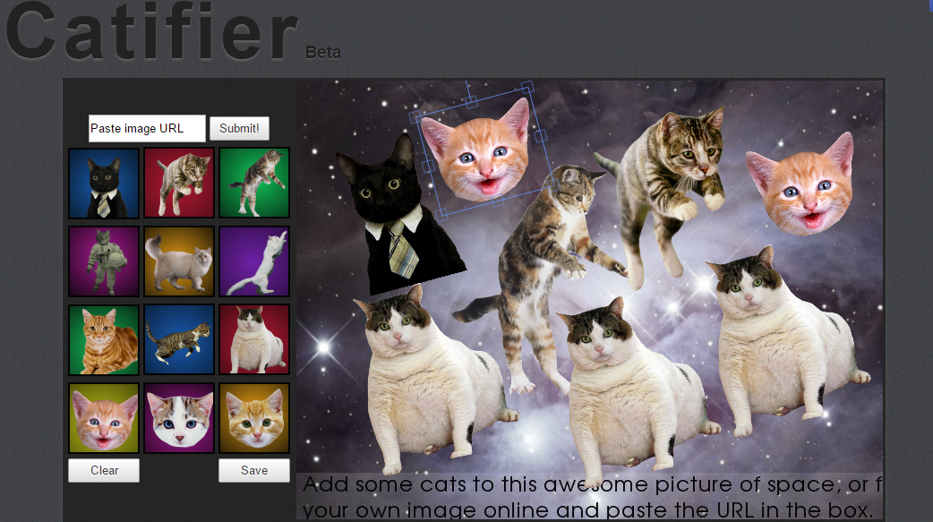

Fabric has several features. It allows you to work with objects in a much simpler way than typing “move to” and “line to xy” for example. You can create complex shape objects whilst having control of their properties such as opacity etc with fewer lines of code.

Anything that simplifies a process especially within coding has the potential to become popular. In this case I feel the potential for community input has helped Fabric grow. Also the technical competency of the framework helps, if it wasn’t practical, no-one would use it.

*Standard code for JS rectangle*

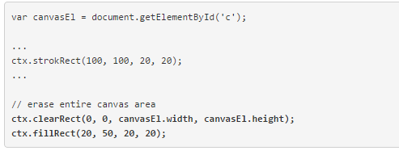

*Fabric code for JS rectangle*

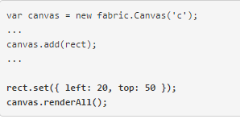

It’s difficult to say how long it would take to fully learn fabric so that you could build a system for a client with it. Ignoring personal traits like application and focus it shouldn’t take too long to become fully versed in Fabric. Personally I find animation much more difficult than the simple drawing on the canvas.

I’m unsure on the risks of using frameworks in general, other than there is a danger that others may come up with similar looking work to your own (bootstrap, especially the navigation).